***Assignment # 7***

|  |  |
| --- | --- |
| **Name** | Muhammad Asad |
| **Roll #** | 2019-EE-383 |
| **Section** | A-G1 |



***Programming Fundamentals***

**Lab # 7**

* **Objectives:**
* The First objective of this lab is to develop the concept of loops.
* To prove the usefulness of Loops in programming by performing some applications and simple mathematical problems.
* **Task#1:**

Use for loop to make the following shape:

* * * * * *

* * * * *

* * * *

* * *

* *

*

Note: use only one * with print.

* **Code:**

import java.util.Scanner;

public class NewClass {

/**

* @param args the command line arguments

*/

public static void main(String[] args) {

Scanner i = new Scanner(System.in);

System.out.println("Provide the number of rows: ");

int rows = i.nextInt();

for (int j= rows-1; j>=0 ; j--){

for (int l=0; l<=j; l++){

System.out.print("*" + " ");

}

System.out.println();

}

* **Output:**

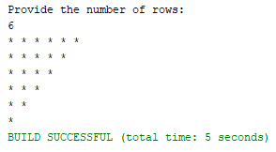

* **Task#2:**

Write a program using for loop which displays all the prime numbers from 50 to 100.

* **Code:**

import java.util.Scanner;

public class NewClass {

/**

* @param args the command line arguments

*/

public static void main(String[] args) {

try (Scanner i = new Scanner(System.in)) {

System.out.println("Set a starting number");

int start=i.nextInt();

System.out.println("Set a last number");

int end=i.nextInt();

System.out.println("prime numbers between "+start+" and "+end+" are");

int count;

for (int j = start; j<=end; j++) {

count=0;

for(int k=1;k<=j;k++){

if(j%k==0)

count=count+1;

}

if(count==2)

System.out.println(j);

}

}

}

}

* **Output:**

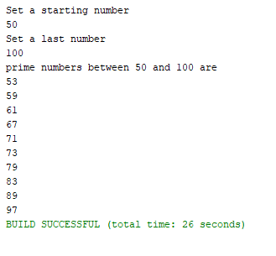

* **Task#3:**

Make the following shape using for loop:

*

* * *

* * * * *

* * *

*

Challenge: use only one * with print.

* **Code:**

import java.util.Scanner;

public class NewClass {

/**

* @param args the command line arguments

*/

public static void main(String[] args) {

int i, j, k, m = 1;

System.out.print("Provide me the number of rows: ");

Scanner o = new Scanner(System.in);

i = o.nextInt();

m = i - 1;

for (k = 1; k<= i; k++){

for (j = 1; j<= m; j++){

System.out.print(" ");

}

m--;

for (j = 1; j <= 2 * k - 1; j++){

System.out.print("*");

}

System.out.println("");

}

m = 1;

for (k = 1; k<= i - 1; k++){

for (j = 1; j<= m; j++){

System.out.print(" ");

}

m++;

for (j = 1; j<= 2 * (i - k) - 1; j++){

System.out.print("*");

}

System.out.println("");

}

}

}

* **Output:**

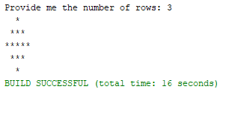

* **Task#4:**

Write a program to check whether a number is a palindrome or not.

* **Code:**

public class NewClass {

/**

* @param args the command line arguments

*/

public static void main(String[] args) {

int num = 12121, reversedInt = 0, remain, originalInt;

originalInt = num;

while( num != 0 ){

remain = num % 10;

reversedInt = reversedInt * 10 + remain;

num /= 10;

}

if (originalInt == reversedInt)

System.out.println(originalInt + " a palindrome.");

else

System.out.println(originalInt + " not a palindrome.");

// TODO code application logic here

}

}

* **Output:**



* **Task#5:**

Write a program which breaks down an integer in segments and display each digit of the integer in new line.

* **Code:**

import java.util.Scanner;

public class Task_5 {

/**

* @param args the command line arguments

*/

public static void main(String[] args) {

int num, temp, digit, count = 0;

try (Scanner scanner = new Scanner(System.in)) {

System.out.print("Enter any number:");

num = scanner.nextInt();

}

temp = num;

while(num > 0){

num = num / 10;

count++;

}

while(temp > 0){

digit = temp % 10;

System.out.println("Digit at place "+count+" is: "+digit);

temp = temp / 10;

count--;

}

}

}

* **Output:**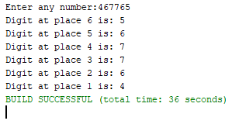

* **Conclusion:**
* Loop is a programming structure that repeats a sequence of instructions until a specific condition is met.
* Loop facilitates iteration of the statements till the specified condition becomes false.
* I concluded that loops are Mother board of programming, they have very vast usefulness and can be used to solve almost every logical problem.